Project Name: E-Commerce Store Analytics Report

Introduction:
This project analyzes the E-Commerce store database through PivotTables, highlighting sales trends across categories, regions, customers, discounts, and payment methods. The findings show strong contributions from Sports, Online channels, Platinum loyalty members, and female customers, along with steady year-on-year growth. Overall, the insights provide a clear view of revenue drivers and customer behaviour, helping guide better business decisions.
Objectives
- Analyze Sales Performance: Evaluate revenue trends across product categories, regions, store types, and time periods to identify key growth drivers.
- Understand Customer Behaviour: Study loyalty levels, gender-based purchase patterns, and top customer contributions to highlight customer preferences and spending habits.
- Assess Discount Strategies: Examine the impact of different discount ranges and distribution across payment methods to determine effective pricing approaches.
- Identify Key Accounts: Highlight top-performing brands and customers that contribute significantly to overall sales, supporting targeted relationship management.
- Track Business Growth: Review yearly and monthly sales trends to measure progress, seasonal variations, and long-term performance.
- Support Decision-Making: Provide actionable insights that help optimize sales channels, strengthen customer loyalty programs, and improve overall profitability
Dataset Description
- Sales Details: Each transaction has a Sales_ID with order date, year, quantity, unit price, discount, and total price. Payment type shows how the purchase was made.
- Customer Details: Customers are identified by Customer_ID, with name, gender, age, and loyalty level recorded to study demographics and loyalty impact.
- Product Details: Products are tracked by Product_ID, category, brand, and cost, helping analyze performance across categories and brands.
- Store Details: Each store has a Store_ID, city, region, and store type (Online, Flagship, etc.), allowing comparison of regional and channel sales.

Data Cleaning Process: Refer Screenshot 1 & Screenshot 2
- In Excel:
  - Removed duplicate records using the “Remove Duplicates” feature.
  - Handled missing values in the Product Cost, Unit Price, Discount % and Total Price with the formulas like Discount % = 1- Total Price /Unit Price * Quantity, Total Price = Quantity * Unit Price * (1 – Discount %) and Unit Price = Total Price /Quantity * (1-Discount %)
  - Standardized formats for dates, text entries (Male/Female, Gold/Platinum), and discount percentages.
  - Applied Find and Replace to standardize and correct inconsistent values in the Customer_ID and Product_ID columns, ensuring data integrity.
  - Applied conditional formatting to spot errors or outliers in cost and price fields.
  - All columns were converted to the correct data types for accurate analysis. IDs (Sales_ID, Customer_ID, Product_ID, Store_ID) were set as text and numeric fields like Cost, Unit Price, Total Price were changed to numbers with Discount % as percentage. Categorical fields such as Region, Store Type, Product Category, Brand, Loyalty Segment, Gender, and Payment Method
- In Power Query:
  - Removed duplicate records using the “Remove Duplicates” feature.
  - Corrected Inconsistencies: Fixed spelling errors in Customer ID, product categories, brand names, and city/region fields.
  - Imported raw tables (Customer, Product, Store, Sales) and merged them into a master dataset.
  - Applied transformations to clean column names, trim spaces, and correct inconsistent text entries.
  - Converted data types (dates, numbers, percentages) for consistency.
  - Automated repetitive cleaning steps so the process can be refreshed easily with new data.
Screenshot 1
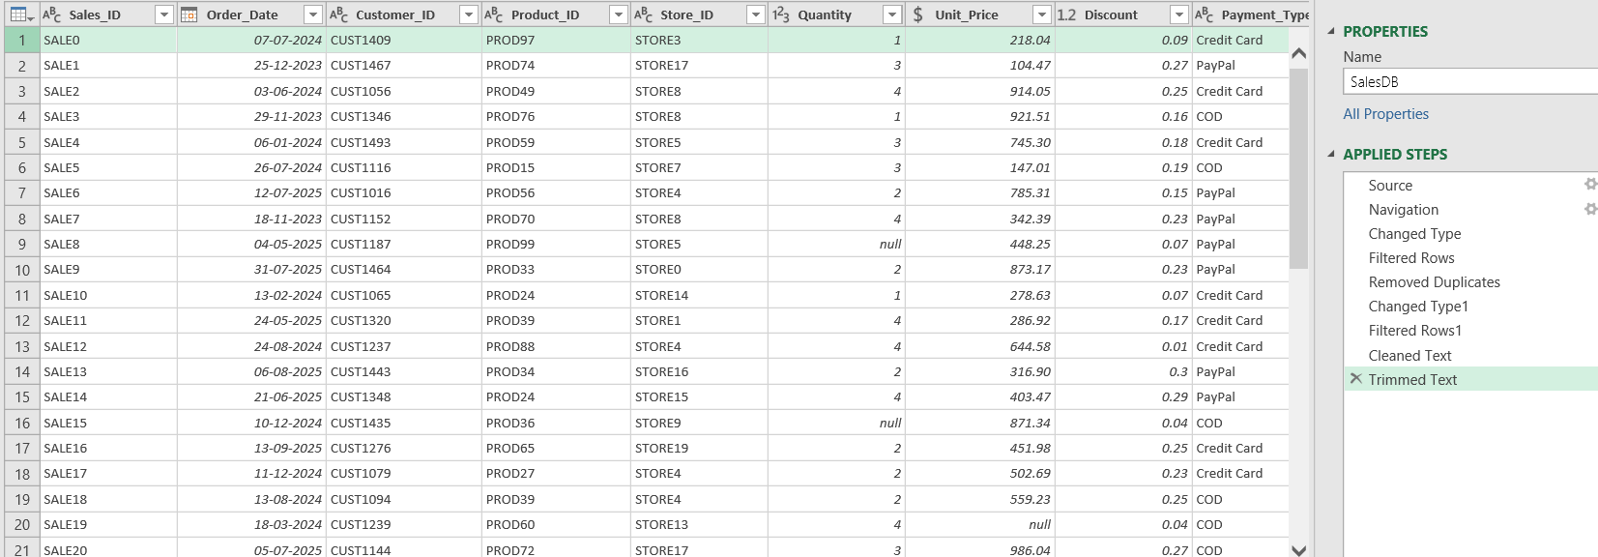

Screenshot 2
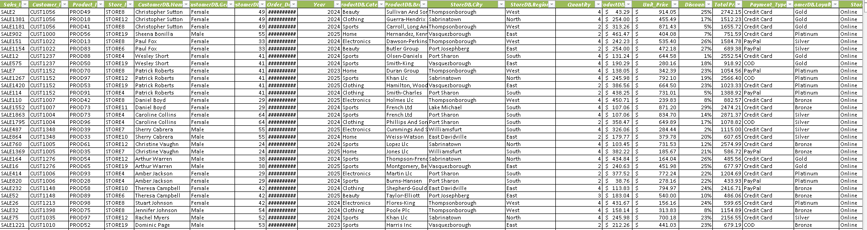
Data Imputation: Refer Screenshot 3
Data imputation is the process of filling in missing or incomplete values in a dataset to maintain consistency and accuracy. In this project, imputation was applied to fields such as Discount %, Unit Price, and Total Price using logical formulas and relationships between variables.
- Discount % was calculated using Unit Price, Quantity, and Total Price.
- Unit Price was derived from Total Price, Quantity, and Discount %.
- Total Price was recomputed using Quantity, Unit Price, and Discount %.
This ensured that all records were complete, reliable, and ready for analysis through PivotTables and dashboards.
Screenshot 3
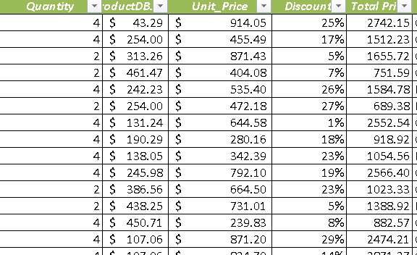

Final Cleaned and Imputed data Set:
Screenshot 4


Data Exploration: Refer Screenshot 5
Descriptive Statistics – Total Price
- The average transaction value is about 1087, while the median is lower at 869, showing more small transactions and a few very large ones.
- The data is spread out widely (range nearly 3890, standard deviation ~820), meaning transaction amounts vary a lot.
- The distribution is positively skewed (skewness ~0.88), so most sales are moderate, but some high-value purchases raise the average.
Descriptive Statistics – Unit Price
- The average unit price is about 514, and the median is close at 523, showing prices are fairly balanced.
- Prices vary a lot, ranging from 20.09 to 999.89, with a standard deviation of about 282.
- The distribution is almost symmetric (skewness ~0), but slightly flatter than normal (kurtosis ~-1.19).
- Overall, most products are mid-priced around 500, but there are both low-cost and high-cost items in the dataset.

Screenshot 5
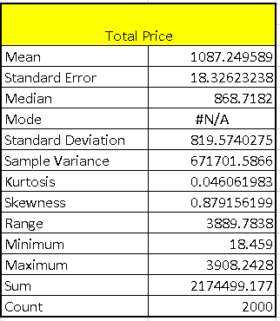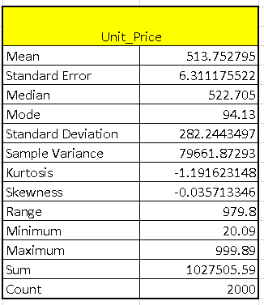
Pivot table: Refer Screenshot 6
- Sales by Product Category:

- Sports had the highest sales with $5,42,009.46.
- Electronics and Home also contributed strongly to overall revenue.
- The store’s total sales reached $21,74,499.18 across all categories.
- Sales by Region & Store Type:

- The East, North, and South regions all made strong contributions, each crossing $3 lakh in at least one channel.
- Online sales were the highest overall at $9,14,252.63, followed by Flagship stores at $8,48,608.03.
- Together, all channels generated a Grand Total of $21,74,499.18.
- Customer Loyalty and Gender Sales Analysis:
- The Platinum segment had the most sales with 616.
- Female customers made more purchases (1,096) than male customers (904).
- Altogether, there were 2,000 sales across all segments.
- Discount Impact on Sales:
- Companies with moderate discounts (13–16%) often had the highest sales — e.g., Hogan-Lee, Lucero Llc, French Ltd.
- Very high discounts (18–20%) did not always lead to big sales — e.g., Cook Inc, Griffin Ltd.
- Overall average discount is 15%, and total sales reached $21,74,499.18.
- Sales Trend by Year:
- Sales grew steadily over the years, starting with $2,23,844.09 in 2023.
- The highest sales were recorded in 2024 at $10,93,911.08, followed by 2025 at $8,56,744.00.
- Altogether, the three years contributed to a Grand Total of $21,74,499.18.
- Top 10 Brand Sales:
- A few companies like Cummings and Sons, French Ltd, and Hogan-Lee recorded the highest sales amounts.
- Overall, the sales from these top customers added up to $3,36,087.33.
- This shows that a small group of key customers contributed strongly to the total revenue
- Average Purchase Value by Gender:
- Female customers had a slightly higher average purchase value at $1,123.58 compared to males at $1,043.20.
- The overall average purchase value across all customers was $1,087.25.
- This shows that female customers tend to spend a bit more per transaction.
- Discount Distribution by Payment Method:
- Discounts were almost evenly spread across payment methods.
- PayPal had the highest share at 34%, while Credit Card and COD each accounted for 33%.
- This shows that all three payment options contributed similarly to overall discounts.
- Top 10 Customers by Sales Value:
- Among the top customers, Jordan Wells recorded the highest sales at $17,147.71, followed by Christy Hoffman and Jay Patel.
- The other customers contributed between $11,800 and $15,400 each.
- Altogether, these ten customers generated a Grand Total of $1,37,354.22.
- Sales Trend by Month:
- Monthly sales stayed fairly steady throughout the year.
- March had the highest sales at $2,10,704.52, while May was the lowest at $1,46,511.96.
- Altogether, the year’s sales added up to a Grand Total of $21,74,499.18.
- Sales by Store Type
- Online stores had the highest sales count with 822 transactions.
- Flagship stores followed closely with 794 transactions.
- Outlet stores contributed 384 transactions, the lowest among the three.

Screenshot 6
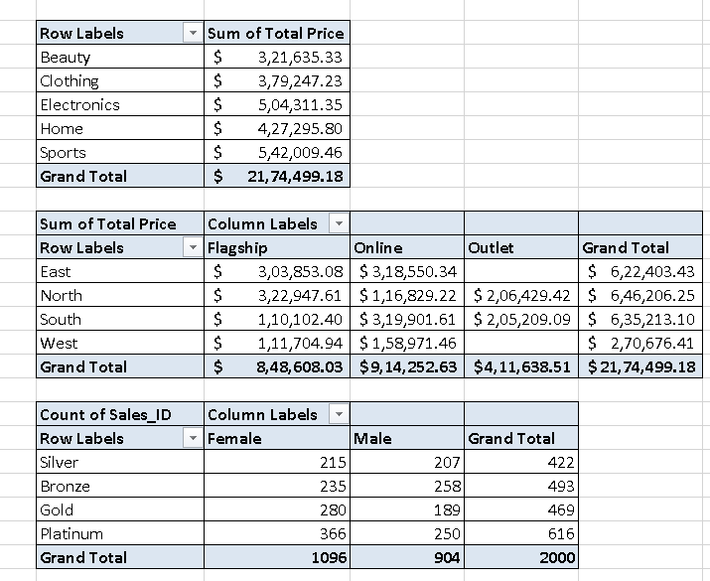

Project Insights:
- Sports category gave the highest sales, showing strong customer demand.
- Online stores are the biggest sales channel, followed by Flagship stores.
- Platinum loyalty customers spend the most, proving loyalty programs work.
- Female customers buy more and spend slightly higher per purchase than males.
- Moderate discounts (13–16%) drive better sales than very high discounts.
- Sales grew steadily, with 2024 being the best year.
- A few top brands and customers contribute a large share of revenue.
- March is the strongest month, while May is the weakest.
- Payment methods are balanced, with PayPal slightly leading in discounts.

Dashboard:
Screenshot 7
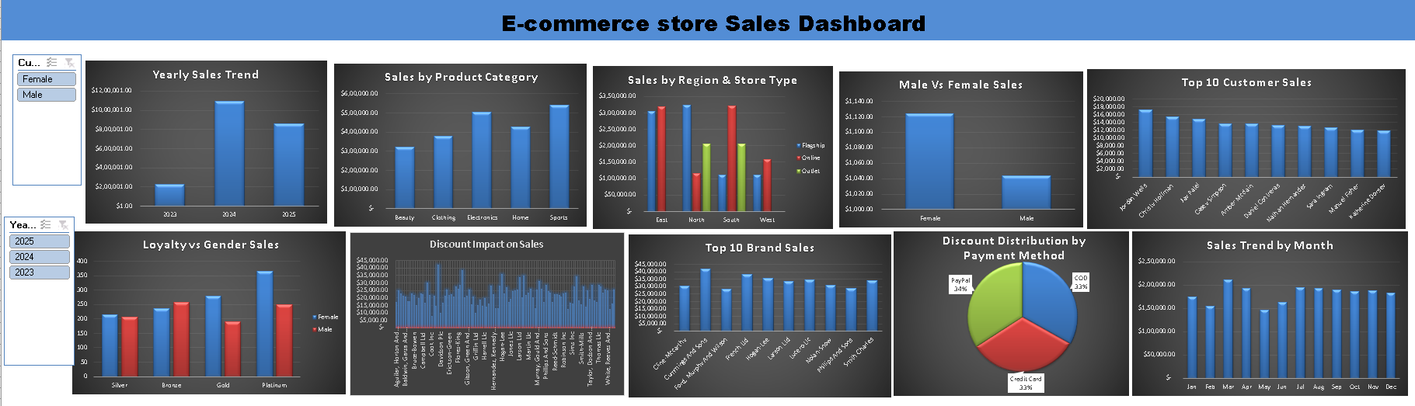

Final dataset:
Screenshot 8
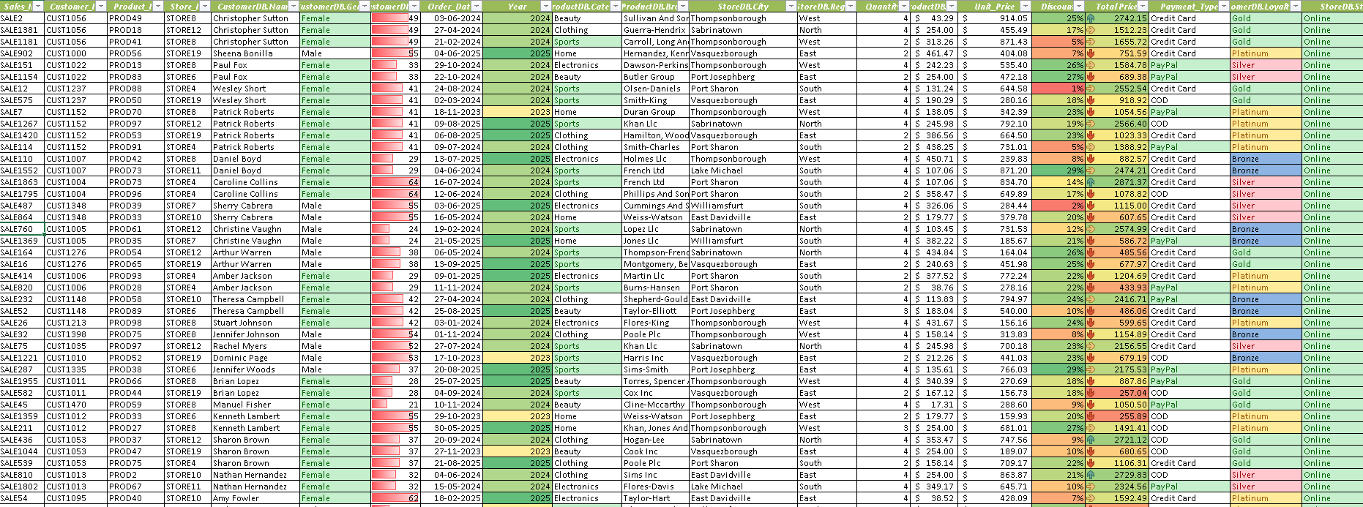

Final Conclusion
The analysis shows that sales are mainly driven by Sports products, Platinum loyalty customers, and online channels. Moderate discounts proved most effective, while female customers purchased more and spent slightly higher per transaction than males. Sales grew steadily across years, with 2024 being the strongest, and monthly trends remained stable apart from seasonal highs and lows. Overall, the project highlights how data cleaning, pivot tables, and dashboards can turn raw sales data into clear insights that guide better decisions in product focus, customer engagement, and sales strategy.

Note: The screenshots in this document are only samples. For complete details, please check the full data in the “Ecommerce_Sales_Dataset_Final Project” Excel file

